Migration and the history of Birmingham: Case Studies
- KS3 Resources
Introduction
Migration has deeply shaped Birmingham as a city. This resource pack contains three case studies for pupils to explore this:
Case Study 1: The National Health Service
Case Study 2: The building of the canals
Case Study 3: Migration to Birmingham since the Second World War

These resources draw heavily on the Migration Museum’s Heart of the Nation: Migration and the Making of the NHS online exhibition and ‘Our City: Migrants and the Making of Modern Birmingham’ by Jon Bloomfield.

Teacher Guidance

These resources are intended for KS3 Pupils. While each case study can be completed in order of activities, each activity can also be studied individually.

There is a glossary attached below, which you may want to use prior to studying each case study.

Warning: Activity 2, in Case Study 1, contains a racist cartoon. Please ensure appropriate discretion is used before introducing pupils to this cartoon. You can see the Migration Museum ‘s tips for using racism sources in the classroom below:

- Before sharing any source material with racist language or imagery in it, it is important that you set your values and expectations.

- Prepare students by acknowledging that the source material you are using has racist language and imagery in it.
- Recognise that for some students the image or language might be personally offensive, so offer a trigger warning at the start of the session and don’t force students to engage with the material if it elicits an emotional reaction.
- We often see people reacting with a trauma response when engaging with racist or discriminatory material (e.g. laughing). This can feel inappropriate, and it can be instinctive to try to shut this type of reaction down, however, as teachers it is important to acknowledge a range of different reactions, and not draw attention to this reaction.

Case Study 1: Migration and the NHS

Activity 1: Please read the following text and answer the questions below.

Text | Questions
“The National Health Service was created in 1948. For many healthcare professionals from Ireland it acted like a beacon, a new model of health care delivered free to all citizens when they needed it. Since the 1930s, UK governments have resolved staffing crises in hospitals by recruiting workers from overseas. The creation of a truly national and innovative health service funded through general taxation made this an attractive proposition to those starting out in their careers abroad. The Irish came to the Midlands in large numbers. They were soon followed by waves from the West Indies and then from other parts of the emerging Commonwealth.  It has been like that ever since. People from all parts of the world - from Fiji to the Philippines, and in more recent times from Poland to Portugal - have come to Birmingham and the rest of the UK to work in the NHS. At the same time, it has offered fulfilling jobs and employment opportunities to the daughters and sons of first-generation migrants already in the city. Across Birmingham today they form a significant proportion of NHS staff working in hospitals, doctors’ surgeries, health centres and outpatients clinics. Many remain on the basic grades but some managed to break through the glass ceiling.”  This is taken from Our City: Migrants and the Making of Modern Birmingham pp.18-19 | How has migration been important to the National Health Service?  Why does the text suggest that the government has chosen to hire people from other countries?  Can you name any countries or regions where NHS workers have come from?

Activity 2: What was the experience of many migrants who arrived to work in the NHS?

Many migrants who arrived to work in the NHS in the early years found it hard to progress their careers. They faced many challenges including discrimination and difficult working conditions. In the 1960s and 70s, many offensive and racist comments were written about immigrant doctors in the correspondence columns of the British Medical Journal, focussing on their alleged lower standards of education and language skills. The popular press soon followed.

Warning: Source B contains racist imagery and language.

Source A: Dr Nayyar Naqvi OBE, who arrived in Britain from Pakistan in 1968.

“Those of us who came from India and Pakistan could only get jobs at district general hospitals, which were not as good as they are now. It was virtually impossible for us to get a job in a teaching hospital. And once we became registrars, that was the ceiling.

The applications I sent were rejected just because of my name and where I got my degree. Any interview that I went to, bar one, I got the job. It was a question of getting to the interview
stage”.

Source B: A racist cartoon published in the Evening Standard, 1969. It shows a black surgeon pushing a large circular saw up to the operating table, while the white medical staff look on in doubt. Follow this link and click reveal to view the image.

Task 2.1: Please read through the sources and analyse how useful they are for an inquiry into the experiences of immigrant Doctors and Nurses?

 | Source A | Source B
Who produced the source? Why might this make it useful?
What type of source is it? Why could this be useful?
What does the source reveal?

Task 2.2 Extended Writing Task: Assess how useful sources A and B are for an inquiry into the experiences of migrants who arrived to work in the National Health Service.

Key Vocabulary: Immigration. National Health Service. Discrimination. Hospital.

Sentence Starters:
One way that Source A/B is useful for an inquiry into the experiences of migrants in the National Health Service is…
In addition, the source is also useful because…
Source A/B gives important information about…

Please write your answer below:
…………………………………………………………………………………………………………………………………………………………………………………………………………………………………………………………………………………………………………………………………………………………………………………………………………………………………………………………………………………………………………………..
……………………………………………………………………………………………………………………………………………………………………………………………………………………………………………………………………………………………………………………………………………………………………………………………………………………………………………………………………………………………………………………
Case Study 2: The Building of Canals
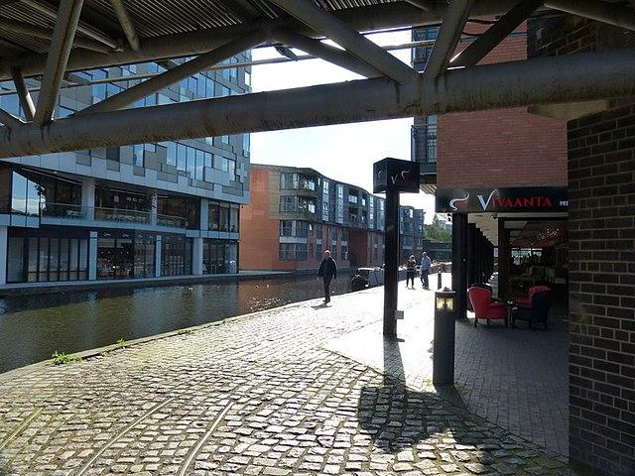
Birmingham’s canals are a central part of the city. They stretch for over 100 miles - that means Birmingham has more Canals than Venice. They were built over 50 years with construction on the first Canal beginning in 1768 and the Worcester and Birmingham Canal not being completed until 1815. These Canals were primarily built by rural English and Irish labourers, who had migrated to Birmingham to find work.

Activity 1: Please read over the reading sheet below and answer the comprehension questions below.

The construction of Birmingham’s canal network in the late 18th century and early 19th centuries was a huge task that relied heavily on the work of thousands of migrant workers, particularly English and Irish labourers. These migrants experienced incredibly difficult working conditions. Employed primarily as navvies, they carried out the physically exhausting and often dangerous work of cutting, digging, and shaping canal routes by hand. Using basic tools such as picks and shovels, they worked long days with very little protection from being injured while working. It was not uncommon for navvies to lose their lives on the job.

Hierarchies were created between the migrant workers on the basis of where they had come from. Irish workers were often given the most tiring and dangerous work. Because English labourers spoke the same language and had a more similar culture to their employers, they were often given slightly better work. Conflict between different groups of workers was common. Living conditions were equally harsh. The canals were dug through farmland or undeveloped areas, so workers had to live in temporary camps close to the construction sites. Those camps lacked basic sanitation and were overcrowded. Diseases like cholera and dysentery spread easily, particularly in wet weather when drainage was poor. Workers lived far from their families, leading to isolation and loneliness.

Migrant workers faced widespread hostility from the local population and even from fellow workers. Stereotypes about Irish workers being violent and drunk were spread by local newspapers and this led to discrimination. Despite difficulty, migrant workers developed strong bonds with each other and often did their best to look after one another. Even in this challenging environment, this allowed migrants to support one another and help keep their cultural and religious traditions.

The impact of migrant labour on the development of Birmingham’s canals was enormous. Without these labourers, the canals could not have been built as quickly or as well. The canals became incredibly important transport routes during the Industrial Revolution. They - and the migrant labourers who built them - played a key role in creating modern Birmingham.

Questions
- Where did migrant labourers come from?

- What tools did they use?

- Describe two challenges that migrant labourers faced?

- ……………………………………………………………………………………………………………………………………………………………………………………………………………………………………
- ……………………………………………………………………………………………………………………………………………………………………………………………………………………………………
- Why might English labourers have had a better experience than Irish labourers?

…………………………………………………………………………………………………………………………………………………………………………………………………………………………………………………………
…………………………………………………………………………………………………………………………………………………………………………………………………………………………………………………………

Activity 2: Imagine you are a historian investigating how migration impacted the building of the Birmingham canals. Please write a short summary paragraph about the experiences of migrants who were involved. What challenges did they face? How did they meet those challenges?

………………………………………………………………………………………………………………………………………………………………………………………………………………………………………………………………………………………………………………………………………………………………………………………………………………………………………………………………………………………………………………………………………………………………………………………………………………………………………………………………………………………………………………………………………………………………………………
…………………………………………………………………………………………………………………………………………………………………………………………………………………………………………………………
…………………………………………………………………………………………………………………………………………………………………………………………………………………………………………………………

Activity 3: There were many reasons why migrants decided to come to Birmingham to work on the canals. We can think of these in terms of push and pull factors.

Push Factors: Reasons why migrants decided to leave their place of origin.
Pull Factors: Reasons why migrants were attracted to come to Birmingham.

Task: Please organise the following reasons why migrants decided to move to Birmingham into ‘Push’ and ‘Pull’ Factors. The first has been done for you.

The building of canals created a need for workers. | Wages for building canals were higher than pay for working on farms. | There was widespread poverty and a lack of jobs in western and southern Ireland.
Pull factor
The government had created laws that displaced poorer English farmers. | There were regular food shortages in parts of Ireland. | Employers sometimes paid for the travel costs of migrants to get to Birmingham.
During certain times of the year, there were no jobs in rural England and Ireland. | Previous migrants provided information and support to help with moving. | Birmingham’s booming industries promised future employment with better wages.

Activity 4: Answer the following question below: ‘Explain why migrants decided to move to Birmingham’. Make sure to include both push and pull factors.

Key Vocabulary: Immigration. Navvies. Employment. Working Conditions

Sentence Starters:
One reason why migrants decided to come to Birmingham was…
This led to migration because…
English/Irish migrants were attracted by…

Please write your answer below:

……………………………………………………………………………………………………………………………………………………………………………………………………………………………………………………………………………………………………………………………………………………………………………………………………………………………………………………………………………………………………………………
……………………………………………………………………………………………………………………………………………………………………………………………………………………………………………………………………………………………………………………………………………………………………………………………………………………………………………………………………………………………………………………
…………………………………………………………………………………………………………………………………………………………………………………………………………………………………………………………………………………………………………………………………………………………………………………………………………………………………………………………………………………………………………………...
……………………………………………………………………………………………………………………………………………………………………………………………………………………………………………………………………………………………………………………………………………………………………………………………………………………………………………………………………………………………………………………

Case Study 3: Building and Rebuilding the City: Birmingham since the Second World War

Task 1: Please read the information sheet below.

Since the end of the Second World War, Birmingham has experienced a series of waves of migration. In the 1940s and 1950s, large numbers of migrants arrived from Ireland, Italy, Poland, as well as from Britain’s colonies in the Caribbean, particularly Jamaica, Barbados and Trinidad and Tobago. This movement was supported by the British Nationality Act of 1948, which was a law giving Commonwealth citizens the right to live and work in Britain. Many of these early migrants were recruited because Britain needed workers in manufacturing, engineering, transport and for the NHS.

From the 1950s to the 1970s, increasing numbers of migrants came from India, Pakistan and Bangladesh. Many worked in Birmingham’s metal industries, car factories, including the Longbridge motor works, while others worked in textile production, catering and retail. In 1972, thousands of people of Indian heritage were expelled from Uganda by Idi Amin and resettled in Birmingham, where they set up small shops and other businesses. This played a key role in reviving high streets in areas where traditional British-owned shops had been closing.

In the 1990s, refugees from Bosnia and Herzegovina settled in Birmingham during and after the Yugoslav wars, some taking jobs in construction, small-scale manufacturing, and catering. In the 2000s, asylum seekers arrived from Somalia, Iraq, and Afghanistan. After 2004, large numbers of migrants arrived from Poland, Lithuania, Slovakia, and Romania, often working in construction, pubs and restaurants and warehouses.

Task 1: Using the map below, please highlight countries that migrants moved to Birmingham from.

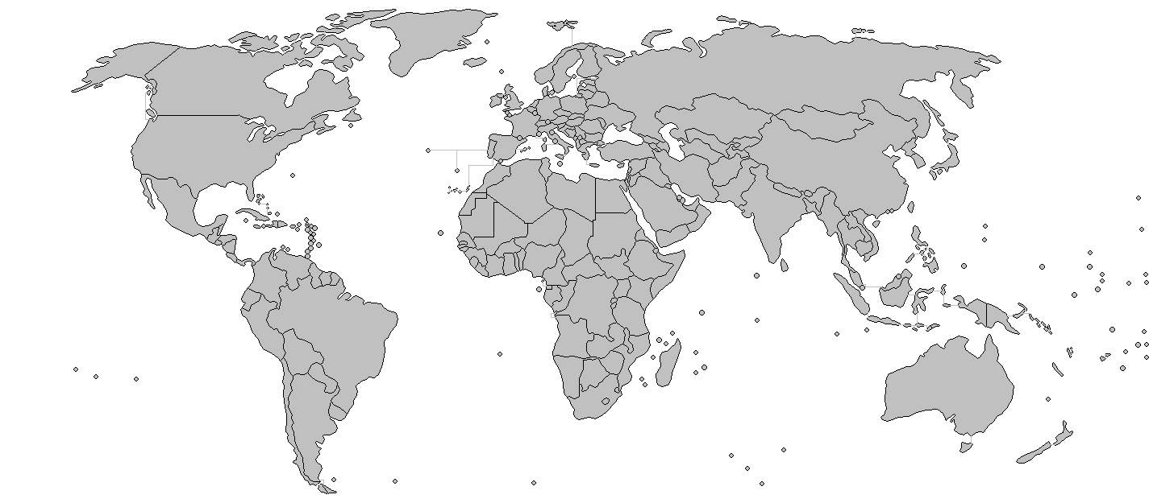

Task 2: For each period of time, please identity what groups of migrants arrived and what jobs they did.

Time Period | Migrants Groups | What are some of the jobs that migrants performed?
1940s-1950s
1950s-1970s
1990s
2004-Present

Task 3: Please read Sources A and B below. They tell the stories of either first or second generation migrants and the jobs and work they have done.

Source A: This is an extract from Our City by Jon Bloomfield. Rehman is one of five children born to parents from Chakswari, near Mirpur in Pakistan. He created and ran his own shop.

‘I get up at five thirty; go to the shop; sort out all the newspapers and deliveries. Then stay there all day. In the shop I sell papers and magazines, cigarettes, plus sweets, ice cream, food and drinks. I am on my own. I’m happy doing what I am doing, its basic stuff. The profit margins are quite high, helped by people going to the park. I close at four in the winter and stay open until six or six thirty in the summer. I am open seven days a week, every day apart from Christmas Day. I haven’t had a holiday for twenty-three years. In the winter you get less

customers, it can be very quiet and it’s a bit depressing. In the summer with more customers it is better. But if you have been doing it for a long time you just get used to it. It’s okay.’

Source B: This is an extract from Our City by Jon Bloomfield. It tells the story of Ben who first came to Birmingham in 2008 from Nigeria to do a Masters Degree in Project Management.

‘Before he left, he put in for a Ph.D on sustainability and social issues… To his surprise his application was successful, he gained a studentship funded by the university and started properly in February 2011, finishing in June 2014… Alongside his research, he did bits of teaching; co-published a few articles; and towards the middle and end of his work began to meet other overseas students and make a wider set of friends - nurses, City Council employees, a lawyer etc.’

Source C: This is an extract from Our City by Jon Bloomfield. It tells the story of Akram whose parents came to Birmingham from Mirpur in 2008.

‘Akram has been a driver for twelve years. His parents came to Birmingham from Mirput in the 1960s. His dad worked in the paint shop at the British Leyland car plant in Washwood Heath for twenty years. Before becoming a taxi driver, he worked in a series of industrial jobs, his last one making radiators and heating equipment. He left there after a bout of redundancies. As the redundancies began and his job started changing he began learning ‘the knowledge’ so that when he lost his job, he was in a position to take up taxi driving. He works days, renting the vehicle from a mate. He is on the road twelve hours a day, seven days a week, apart from Friday when he takes a two-hour break to go to prayers. After all the costs are accounted for, he earns £450 a week.’

Task 4: Imagine you are a journalist who has been asked to write a newspaper article about how migration has impacted the economy of Birmingham.

Step 1: Write down every way that migration has impacted Birmingham. Use individual examples where you can. The first one has been done for you.

- Some migrants have helped by starting businesses. For example, Rehman created and ran his own shop.

Step 2: Plan your article by filling out the table below.

Instruction | Answer
Headline: Think of one catchy sentence that sums up what you have learned today.

For example: ‘New Neighbours, New City: How Migration has helped Birmingham’
Paragraph 1: New Businesses. What have you learned today about how migrants have created new businesses?
Paragraph 2: Working? What kind of jobs have migrants worked in? Can you think of any examples?
Paragraph 3: Anything else? How else has migration had an impact on Birmingham?

Step 3: Write your newspaper headline and article below.
Birmingham Times!

Headline:.....................................................................................................................................
Article:
………………………………………………………………………………………………………………………………………………………………………………………………………………………………………………………………………………………………………………………………………………………
………………………………………………………………………………………………………………………………………………………………………………………………………………………………………………………………………………………………………………………………………………………
………………………………………………………………………………………………………………………………………………………………………………………………………………………………………………………………………………………………………………………………………………………
………………………………………………………………………………………………………………………………………………………………………………………………………………………………………………………………………………………………………………………………………………………
………………………………………………………………………………………………………………………………………………………………………………………………………………………………………………………………………………………………………………………………………………………
………………………………………………………………………………………………………………………………………………………………………………………………………………………………………………………………………………………………………………………………………………………
………………………………………………………………………………………………………………………………………………………………………………………………………………………………………………………………………………………………………………………………………………………

Glossary
Application – A formal request to be accepted for a job, course, or opportunity.
Asylum seeker – Someone who has left their country and asks to live in another country because it’s unsafe to return.
Attractive proposition – An offer or idea that seems appealing and worth considering.
Barrier – Something that stops progress or makes it harder to achieve a goal.
Basic grades – The lowest level of jobs in an organisation.
Beacon – A signal or example that inspires or guides people.
Booming industries – Businesses that are growing very fast and making a lot of money.
Bout (of redundancies) – A short period when many people lose their jobs.
British Nationality Act 1948 – A law giving people from Commonwealth countries the right to live and work in Britain.
Canal network – A connected system of man-made waterways for boats.
Career – The jobs someone does during their working life.
Case study – A detailed look at one example to learn more about it.
Ceiling (career) – A limit that stops someone from getting promoted or reaching higher levels in their job.
Cholera – A serious illness caused by dirty water, leading to severe diarrhoea and dehydration.
Citizens – People who belong to and have rights in a particular country.
Commonwealth – A group of countries, many once part of the British Empire, that work together on shared goals.
Comprehension – Understanding something that you read or hear.
Construction – The process of building something.
Culture – The beliefs, customs, and traditions of a group of people.
Depressing – Making you feel very sad or hopeless.
Discrimination – Treating someone unfairly because of who they are.
Displaced – Forced to leave your home.
Drainage – How water is removed from land or roads.
Economy – How a place makes and uses money, goods, and services.
Emerging – Starting to become known or important.
Employment – Having paid work.
Engineering – Designing and building machines, structures, or systems.
Equality – Treating people fairly and giving them the same opportunities.
Evidence (historical) – Information or sources used to understand the past.
Expelled – Forced to leave a place.
Factory – A building where goods are made.
Fiji / Philippines / Portugal / Poland / Jamaica / Barbados / Trinidad and Tobago / Uganda / Bosnia and Herzegovina / Somalia / Iraq / Afghanistan / Lithuania / Slovakia / Romania – Countries mentioned as places migrants came from.
First-generation migrants – People who move to another country and are the first in their family to live there.
Fulfilling job – Work that makes you feel satisfied and happy.
General taxation – Money the government collects from people and businesses to pay for public services.
Glass ceiling – An invisible limit that stops certain people from getting better jobs.
Harsh – Very difficult or unpleasant.
Healthcare professionals – People whose job is to care for people’s health, like doctors and nurses.
Heritage – The traditions, culture, and history of a person or group.
Hierarchy – A system where people are ranked at different levels of importance or power.
Hostility – Strong dislike or unfriendly behaviour.
Immigration – Moving to live permanently in another country.
Industrial Revolution – A period in the 1700s–1800s when machines and factories changed how things were made.
Innovative – New and creative.
Isolation – Being alone and separated from others.
Job interview – A meeting where an employer asks a person questions to decide if they should get the job.
Labourers – People who do physical work, often outdoors.
Living conditions – The situation in which people live, including housing and health.
Manual labour – Work done by hand or with physical effort.
Manufacturing – Making goods in large quantities, usually in a factory.
Margin (profit) – The difference between the cost to make something and the price it’s sold for.
Master’s degree – A university qualification you can get after a bachelor’s degree.
Migration – The movement of people from one place to another to live or work.
Motor works – A factory where cars are made.
Navvies – Workers who built canals, railways, or other big construction projects.
Nationality – The country where you legally belong.
Outpatients clinic – A place where patients go for treatment without staying overnight in hospital.
Overcrowded – Having too many people in one place.
Overseas – From another country, across the sea.
Painting shop (factory) – Part of a factory where items are painted.
Physical exhaustion – Extreme tiredness from hard physical work.
Poverty – Being very poor.
Project management – Planning and organising work so that a job or project is finished successfully.
Proposition – An idea or offer for someone to consider.
Pull factors – Reasons people are attracted to move somewhere.
Push factors – Reasons people want to leave their home country.
Recruiting – Finding and hiring people for jobs.
Redundancies – When people lose their jobs because they are no longer needed.
Resettled – Moved to live permanently in a new place.
Sanitation – Systems for keeping places clean, like toilets and drains.
Significant proportion – A large part of the total amount.
Source (history) – A piece of evidence used to learn about the past.
Staffing crisis – A serious problem caused by not enough workers.
Statistic – A fact or piece of information in numbers.
Stereotype – A fixed and often unfair idea about a group of people.
Studentship – Money given to a student to help them study.
Sustainability – Using resources in a way that protects the environment and can last for a long time.
Taxation – The system of collecting money from people to pay for public services.
Temporary camps – Places where people live for a short time.
Textile production – Making cloth and fabrics.
Trade union – An organisation of workers that helps protect their rights.
Transport routes – Roads, canals, railways, or other ways goods and people travel.
Uncommon – Not happening very often.
Wages – Money people earn for working.
Warehouse – A large building for storing goods.
Working conditions – The environment and terms under which people work.

