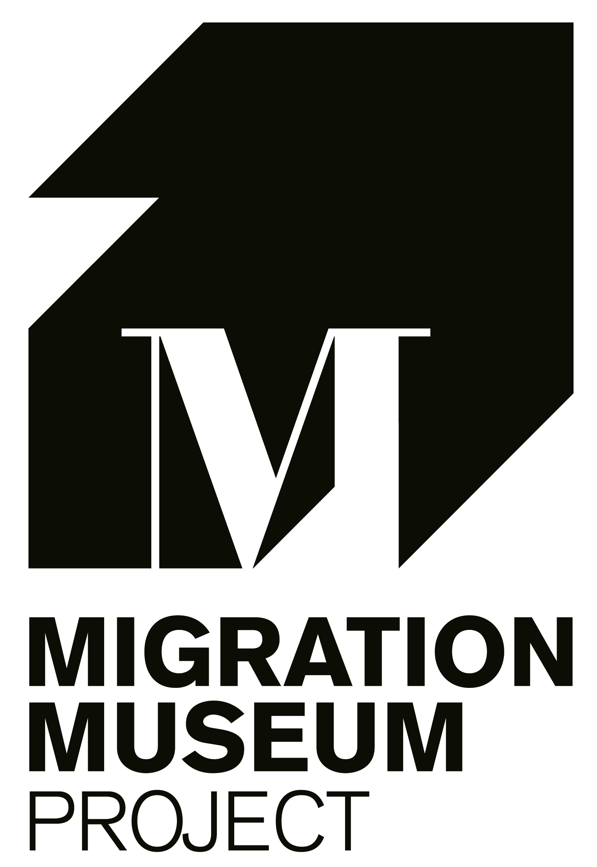
JOB DESCRIPTION AND PERSON SPECIFICATION

Museum Operations Manager

Job title | Museum Operations Manager
Contract type | 5 days per week (Wednesday to Sunday 09.30-17.30) for eight months from mid-February 2020
Salary | £25,000 pro rata salary (£17,750 for nine months) plus matched 5% pension contribution
Job purpose | To manage key operational aspects of the Migration Museum and supervise gallery staff
Location | South-East London
Deadline for applications | Midnight on 22 December 2019
Interviews | Week beginning 6 January 2020 in London

BACKGROUND

The Migration Museum (www.migrationmuseum.org) produces inspiring exhibitions and runs events, education, community and public engagement programmes to shine a light on the many ways that migration to and from Britain across the ages has shaped who we are as individuals, communities and as a nation. Whilst working towards achieving our goal of establishing a permanent London home for the Migration Museum, we have occupied a number of temporary sites, most recently in Lambeth for the past two and a half years.
In January 2020, we are making an exciting move, for at least nine months, to a large retail unit in south-east London, enabling us to bring our offer to entirely new, mass audiences. Our new venue will have a much more substantial presence than hitherto, staging two exhibitions simultaneously (our acclaimed Room to Breathe, to open in mid-February 2020, and a new exhibition, Departures, charting 400 years of British emigration, due to open in April 2020) together with a number of temporary displays. The museum will also have a space for events, education and community workshops, refreshments and a shop.
This move opens up the brand new role of Museum Operations Manager – a key member of staff that we now require in order to deliver a first-class Migration Museum in our new venue.

JOB DESCRIPTION

This is an exciting opportunity for a flexible, approachable, practical organizer with excellent communication skills and plenty of initiative who will have overall responsibility for the practical management and smooth running of the Migration Museum’s new space. A key aspect of this new role will be regularly reporting back to the Migration Museum team to ensure that successes are noted and that challenges and areas for improvement are appropriately and swiftly addressed.
As well as having a down to earth, hands-on approach, the post-holder will also be a highly effective ambassador for the Migration Museum, liaising sensitively and diplomatically with neighbouring commercial tenants, as well as with the museum’s landlord and other stakeholders. The Museum Operations Manager will be a key public-facing member of the museum’s front-of-house team, responsible for engaging daily with a wide cross-section of people, requiring a confident, welcoming manner with the ability to be authoritative if required.
The Museum Operations Manager will be supported by up to two paid gallery supervisors (whose role will primarily be to welcome and engage visitors with our exhibitions) as well by as a number of volunteers, and will be responsible for ensuring that the galleries are adequately supervised at all times by these members of staff and volunteers.
The Museum Operations Manager will be responsible for opening up and closing down the museum (with an ability to oversee troubleshooting of technical museum displays) and for overseeing the smooth running of all the museum’s spaces: ensuring appropriate set-up and take-down for workshops and events, that the shop is fully stocked and the till staffed and secure, that the kitchen and refreshments area is clean and tidy, and that deliveries are received and items stored in an orderly fashion. The role will involve responsibility for handling cash, for some ordering of shop merchandise, office supplies and the like and for a wide range of administrative and other duties as required.
The post-holder must relish working as part of a small, highly motivated team within a fast-paced environment, and have a truly flexible approach to work with an understanding that the demands of this new role may evolve over time.
Responsibilities:
- Overseeing gallery staff and volunteers to ensure effective supervision of galleries, shop and other museum spaces
- Opening up and shutting down the museum, managing technical troubleshooting and making sure spaces are clean, tidy and well-organised
- Ensuring effective set-up and clear-up of museum spaces before and after workshops and events
- Liaising on practical and operational matters with neighbouring tenants and museum stakeholders
- Being a welcoming member of the front of house team, at ease with a broad range of people, ensuring that all visitors have a rewarding experience, and with the ability to manage difficult situations if required
- Handling cash, placing orders and carrying out a wide range of administrative and other tasks as required for the effective and smooth running of the museum
- Attending weekly team meetings and reporting regularly to relevant colleagues within the Migration Museum team on successes, challenges and areas for improvement

PERSON SPECIFICATION
Essential
- Experience of management of people and/or places
- Experience of working directly with members of the public in a community-based organisation and the ability to engage with people from a wide range of backgrounds
- Exceptional interpersonal skills and the ability to build and sustain relationships with people from all backgrounds; tactful, diplomatic and persuasive
- Ability to manage difficult situations or challenging behaviour if necessary
- Exceptional organizational skills, punctuality, and a disciplined approach
- Practical skills and a hands-on approach
- Facility with Microsoft Word and Excel and online document sharing platforms
- Strong initiative and the ability to work unsupervised
- Willingness and ability to undertake a wide range of tasks, including routine tasks
- Collaborative and flexible
- An understanding that this role requires work at weekends
- Understanding of, and commitment to, the aims of the Migration Museum including a sensitivity to controversial issues

Desirable
- Technical troubleshooting and DIY skills
- Experience of working with volunteers
- Familiarity with the local area and communities
- Knowledge of UK migration history
To apply for this position, please e-mail a copy of your CV, of no more than two pages, and a covering letter, of no more than 500 words, to the project director, Sophie Henderson: sophie@migrationmuseum.org

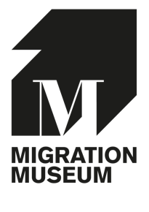

EQUAL OPPORTUNITIES MONITORING FORM

The Migration Museum is committed to the principles of equal opportunities. This includes not discriminating under the Equal Act 2010 and monitoring our workforce for diversity to check whether we need to make any changes to our practices. We need your help and co-operation to enable us to do this, but filling in this form is voluntary. The information you supply on this form will be kept confidentially and anonymously and it has no part in the shortlisting process..

Name:
Position applied for:

Gender:
Male ☐ | Female ☐ |  | Other ☐ | Prefer not to say ☐

Age:
Under 25 ☐ |  | 25-34 ☐ | 35-44 ☐ | 45-54 ☐ | 55-64 ☐ | 65+ ☐ | Prefer not to say ☐

Ethnic Origin (the group to which you perceive you belong):
Asian | Indian  Pakistani  Bangladeshi  Chinese  Other  Prefer not to say |  | ☐  ☐  ☐  ☐  ☐  ☐
Black | Caribbean  African  Other  Prefer not to say |  | ☐  ☐  ☐  ☐
Mixed | White and black Caribbean  White and black African  White and Asian  Other mixed background  Prefer not to say |  | ☐  ☐  ☐  ☐  ☐
White | British  Irish  Other white background  Prefer not to say |  | ☐  ☐  ☐  ☐
Other | ☐ Please specify:
Prefer not to say | ☐

Do you have a disability or impairment?
Yes
No
If yes, please specify, and refer to the last page of this form:
Mobility difficulties (e.g., wheelchair user) |  |  | ☐ |  | Multiple impairments (please specify) | ☐
Hearing impairment or deafness |  |  | ☐ |  | Visual impairment or blindness | ☐
Learning difficulties (e.g., dyslexia, dyspraxia) |  |  | ☐ |  | Invisible disability (e.g., epilepsy, diabetes, asthma) | ☐
Mental health difficulties |  |  | ☐ |  | Other, not listed here (please specify) | ☐

Sexual orientation:
Heterosexual ☐ |  | Lesbian ☐ | Gay ☐ | Bisexual ☐ | Prefer not to say

Religion:
Buddhist | ☐
Christian | ☐
Hindu | ☐
No religion | ☐
Jewish | ☐
Muslim | ☐
Other (please specify) | ☐
Prefer not to say | ☐
Sikh | ☐

Where did you hear about this position?
Social media (e.g., twitter, facebook) | ☐
Migration Museum website | ☐
Other website (please specify) | ☐
From a friend or colleague | ☐
Google | ☐
Other (please specify) | ☐

The Migration Museum welcomes applications from disabled candidates, and we strive to accommodate any specific needs. In order to ensure we can make reasonable adjustments to the interview process, if you answered ‘yes’ to having a disability, please let us know below of any accessibility adjustments you would like us to provide.

If offered an interview, I would require the following assistance or adjustment:

Signature: Date:

Please return this form separately to your application marked ‘strictly confidential’

