Teacher Guide (KS3)
We at the Migration Museum Project are working to establish a national Migration Museum for Britain – a powerful, moving institution that reflects the important role that migration has played in Britain’s history over hundreds of years.

Since receiving core funding in 2013, we have held four exhibitions, numerous events and run an active programme of workshops that have engaged with over 3000 students. We have recently been granted a home for the next year at ‘The Workshop’, a new arts and community space in Lambeth.

From September 2017, we will also be hosting our most ambitious exhibition to date. No Turning Back: Seven Migration Moments That Changed Britain will focus on seven pivotal moments where migration shaped the history of Britain. Additionally, a fantastic programme of workshops and self-directed activities has been created to work alongside school trips to the exhibition.

The following pages are intended to act as a teacher guide and plan for the KS3 lessons that the Migration Museum Project has created to enhance students’ learning experience.

The rest of this guide contains:
- Objectives and Rationale
- Curriculum Focus
- Outline of Pre-Visit (Lesson 1)
- Lesson 1 Slides and Notes
- Outline of Post-Visit (Lesson 2)
- Lesson 2 Slides and Notes
- Engaging Students

If you have any queries regarding the resources or an upcoming workshop, contact our Education Officer, Liberty Melly by email (liberty@migrationmuseum.org) or phone (07825640624). Please let us know what you think of the resources or even share your classroom use of it! We would love to see pupils inspired through our Twitter page @MigrationUK using #NoTurningBack and #MigrationMuseumProject.
Objectives and Rationale
Teaching Aims & Learning Objectives
- to explore and develop students’ working historical knowledge and understanding
- to empower students to search for their own meaning in the past
- to create an educational space for pupils to reflect on current events

Rationale
To speak about migration is to provide a narrative for the movement of people to and from Britain. By its nature the lessons lends themselves to the beginning of a series on migration and/or mutual respect of those with different faiths and beliefs. As it is grounded in an evidential, historical approach to teaching and learning, the lessons are especially suitable for use in History classrooms. This does not preclude it being used in other subjects however.

Key Information
- The lesson is intended for Year 7, 8 and 9 students. It is devised for History classes but has been developed to allow for use with other subjects.
- Timings are suggested on the basis of a one-hour lesson and may need modifying accordingly depending on the abilities of the class in question.
- Prior knowledge is not needed. However, do not underestimate the knowledge and preconceptions your students may already have.
- For this lesson you will need the accompanying PowerPoint and Resource Pack.
- The following lesson plan should be read and used in conjunction with guidance on the accompanying PowerPoint slides.

Curriculum Focus
History
The moments are from a variety of historical contexts and periods. They reflect the process of change in migration and the relationship between different groups of people. The topics allow pupils to consider their own identity and challenges in our time, as well as analyse trends and make connections between events.

Humanities
A number of the moments can be used to explore Humanities topics, including population, urbanization and the human impact on the environment. Our exhibition explores tareas of social, moral spiritual and cultural education (SMSC) and British Values. At it’s core, it considers the concept of a common humanity and personal experience.

Citizenship
Many of these topics tap into citizenship themes such as local and national identity, the precious liberties enjoyed by UK citizens and the ways in which people work together for communities, as well as globalisation and global issues, alongside the impact of the media.

English
No Turning Back can be utilised to explore the English purpose of study, including the oral evaluation of viewpoints, the ability to make inferences and refer to evidence, participation in formal debates and structured discussion, and the identification of bias and opinion.

Art and Design
The exhibition contains the work of numerous artists. These are exhibited in order to illustrate the migrant experience. As such, the moments also demonstrate the contribution art and design can have to our understanding of culture. Students may choose to use the research we present to identify user needs and possible community contributions.

Outline of Pre-Visit (Lesson 1)
Introduction: Migration Museum Project and No Turning Back (4 Minutes)
Provide a brief explanation of the museum’s purpose and the exhibition.

Starter: Famous Faces (7 Minutes)
The starter aims to engage pupils with famous faces of migrants.

Key Definitions and Lesson Objectives (3 Minutes)
Certain key definitions and the lesson objectives should be shared with the class.

Activity: Timeline (7 Minutes)
This activity allows pupils to organise the exact dates and titles of the seven moments.

Activity: The Seven Moments (15 Minutes)
Greater detail on the seven event is now provided to the class.

Activity: True or False (5 Minutes)
This activity is a chance to check the class comprehension of the seven moments.

Activity: The Lens of Brexit (7 Minutes)
This activity looks at art as a response to an event – specifically Brexit as a pivotal moment.

Plenary: Response (12 Minutes)
Pupils are to be asked for words that they associate with each event and the reasons that the migration moment occurred. Similarities and differences can then be explored.

Lesson 1 Slides and Notes
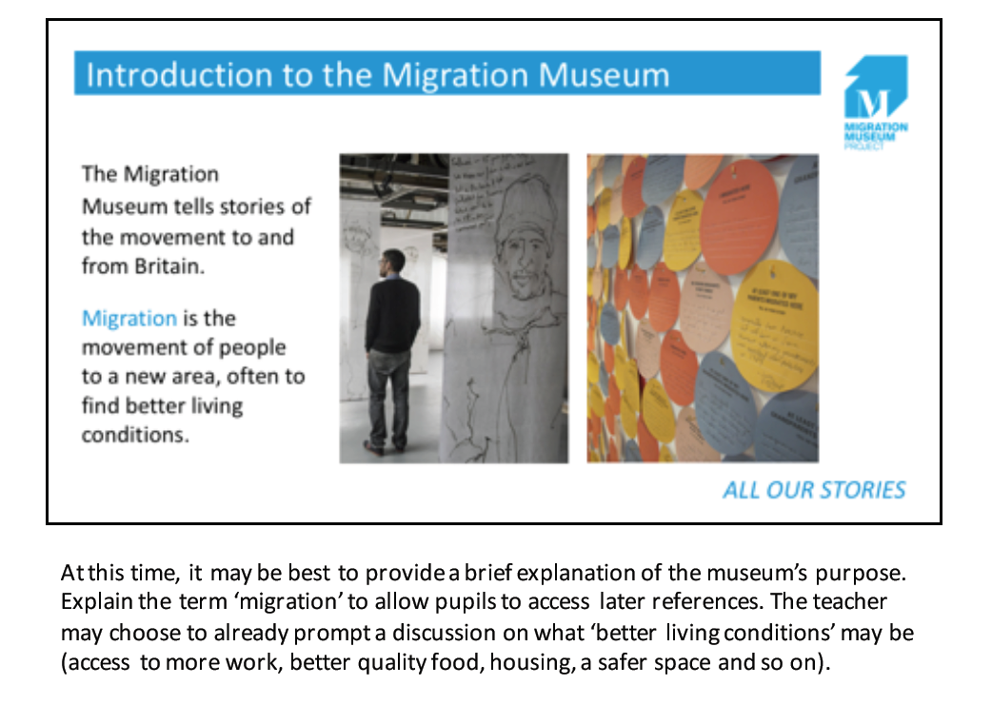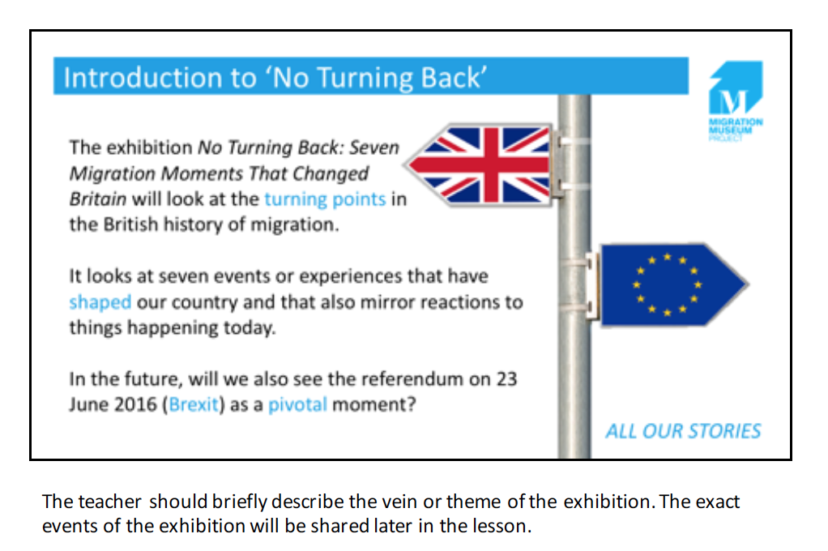

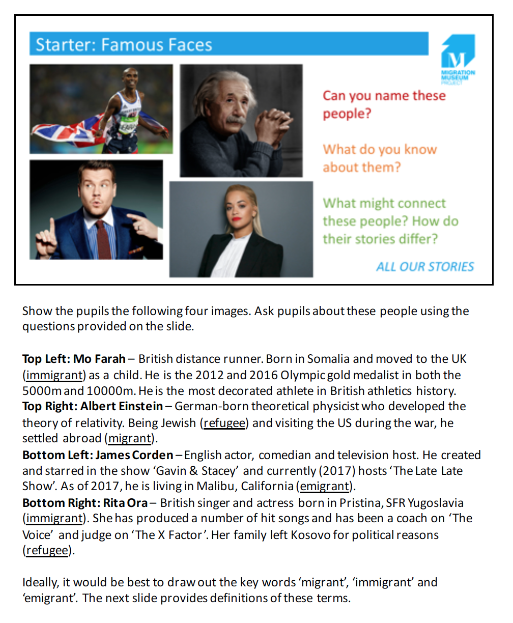

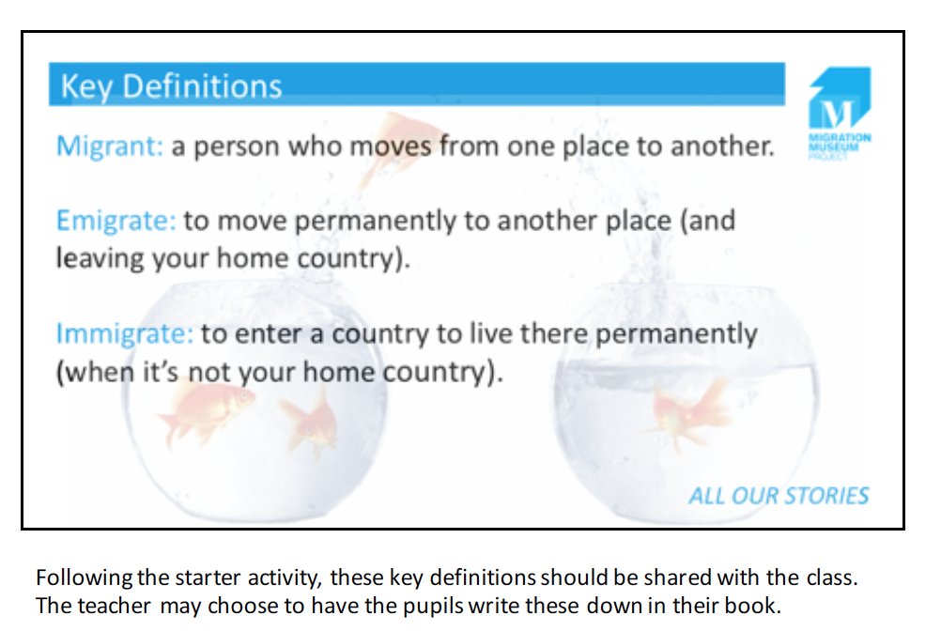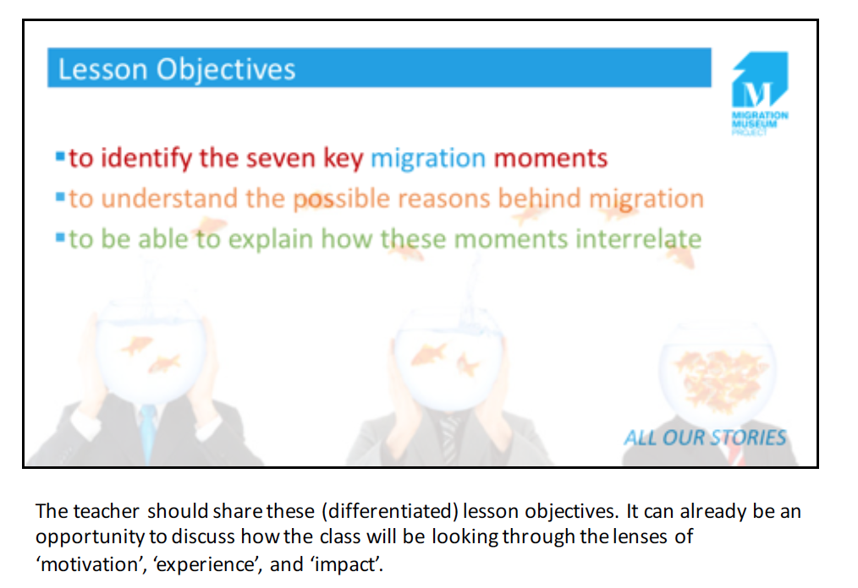

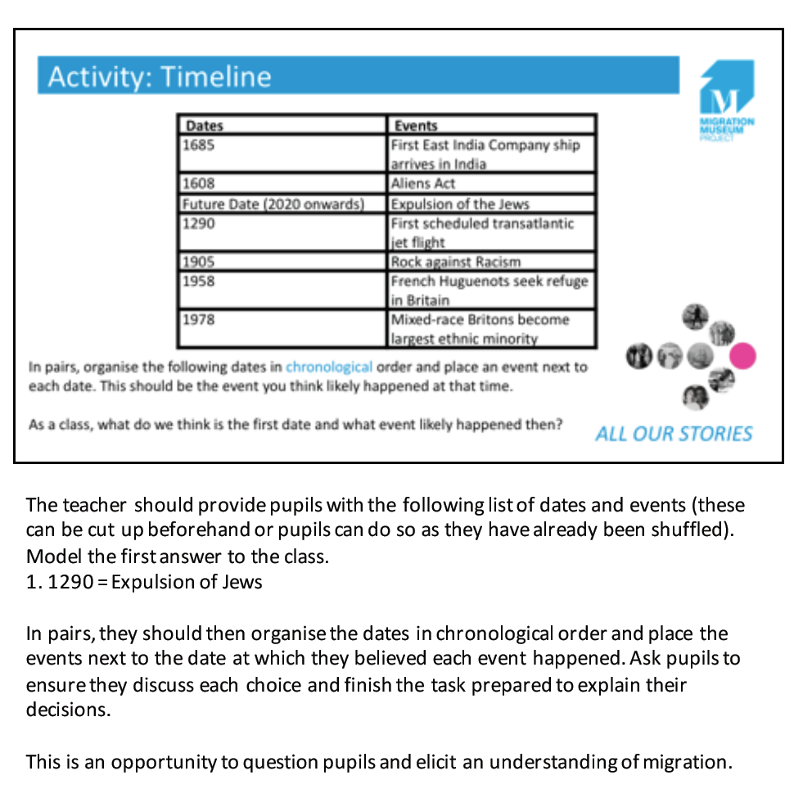
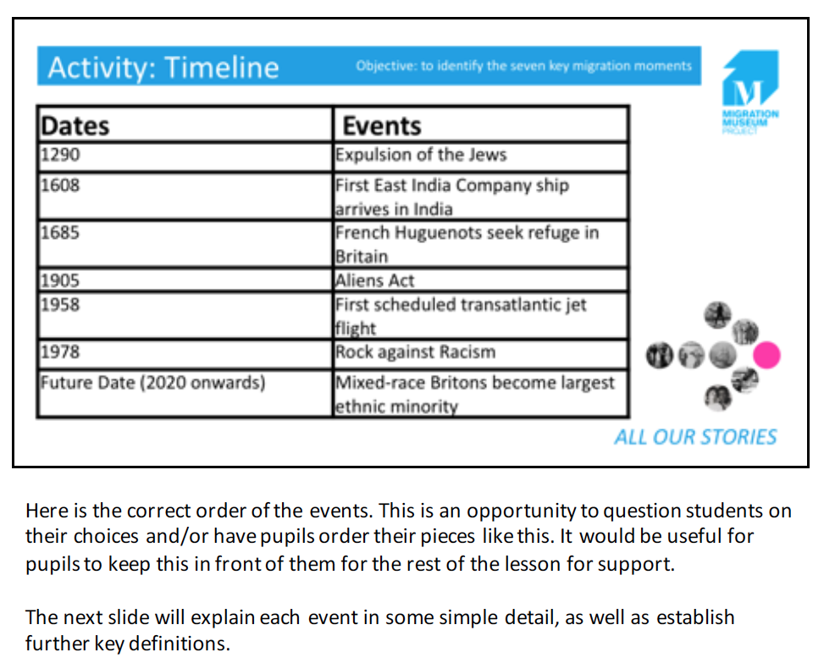

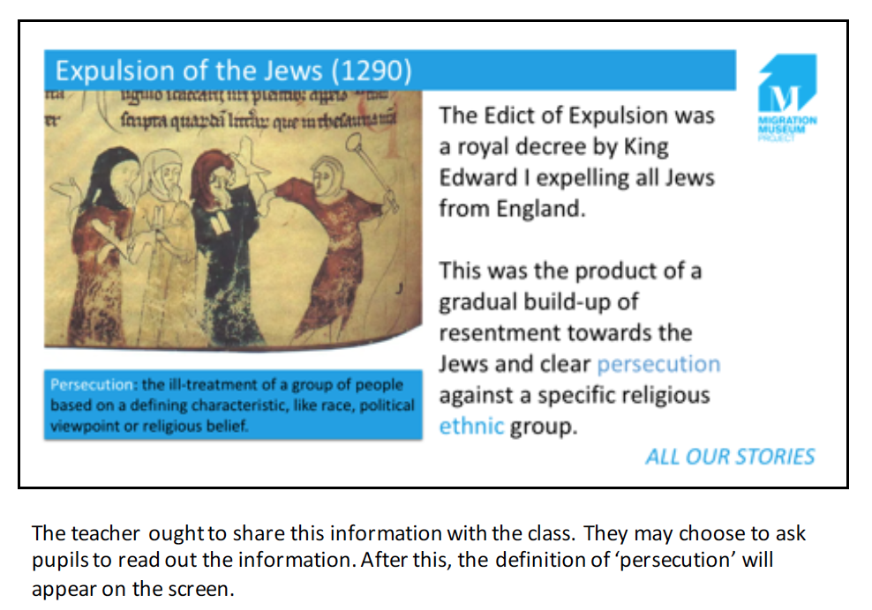
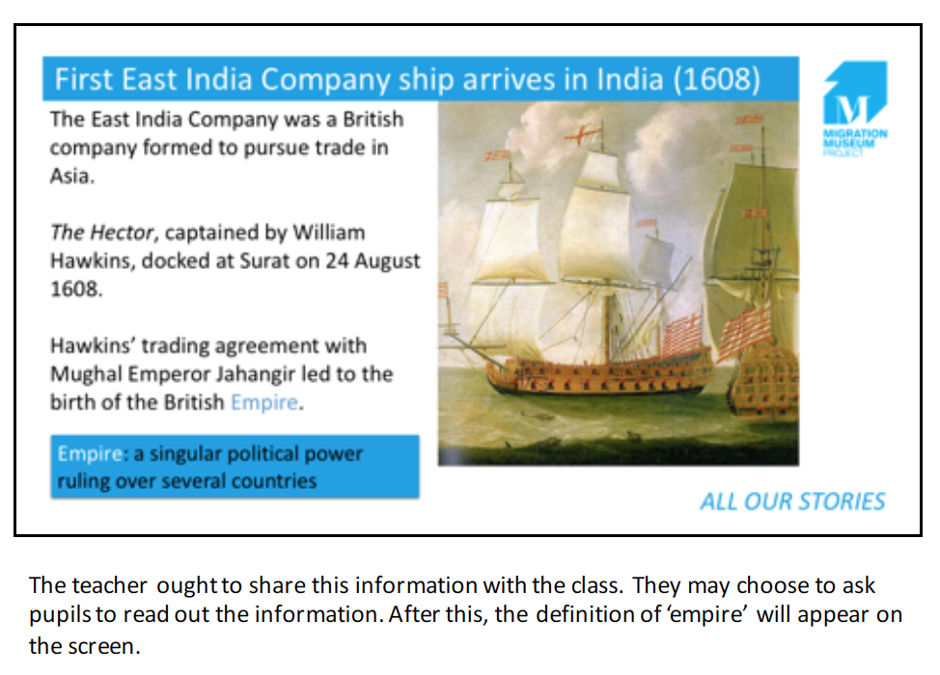

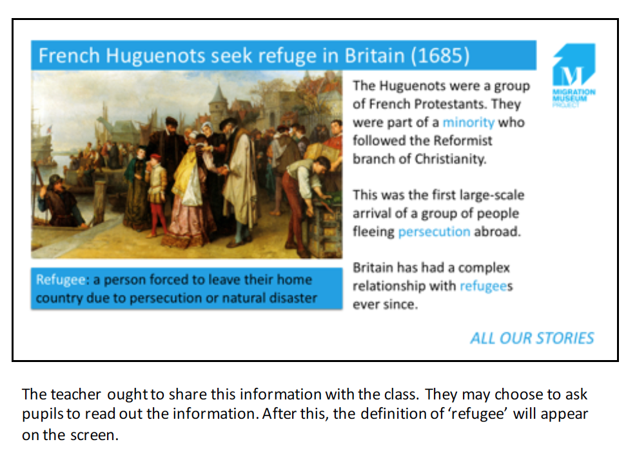
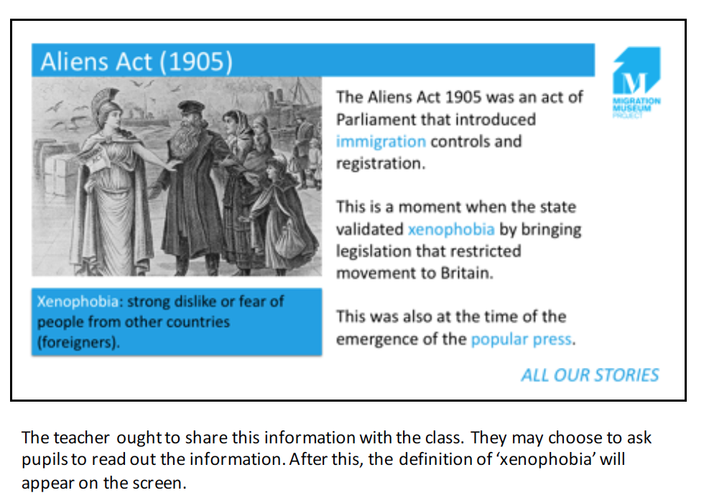

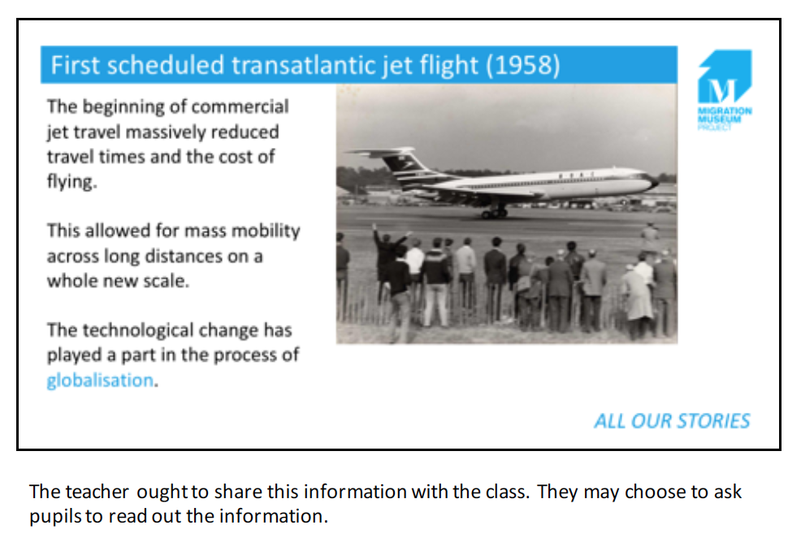
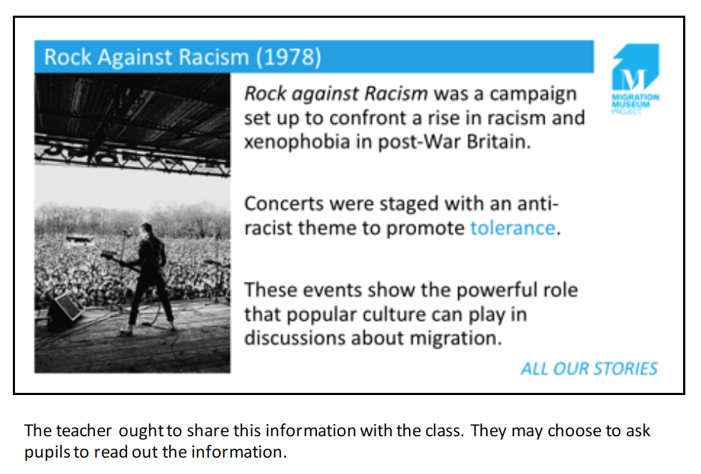

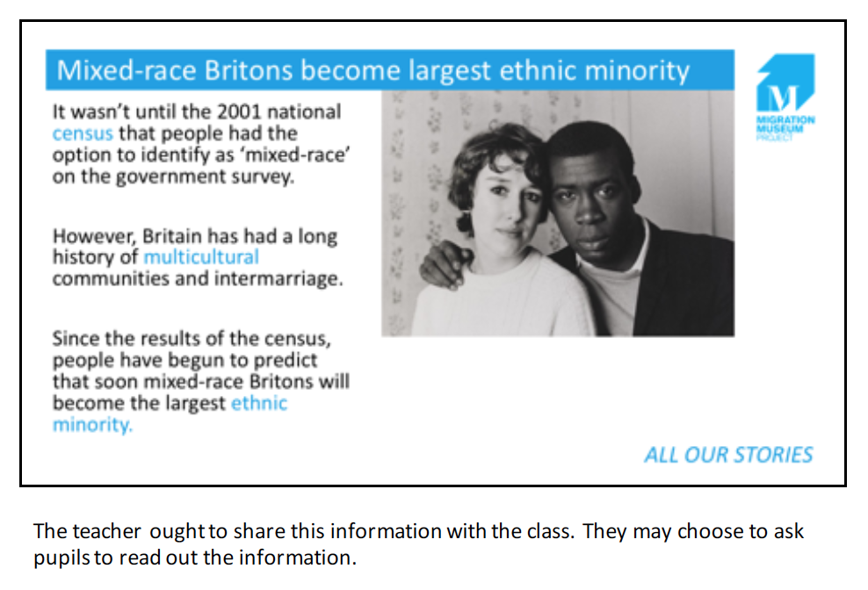

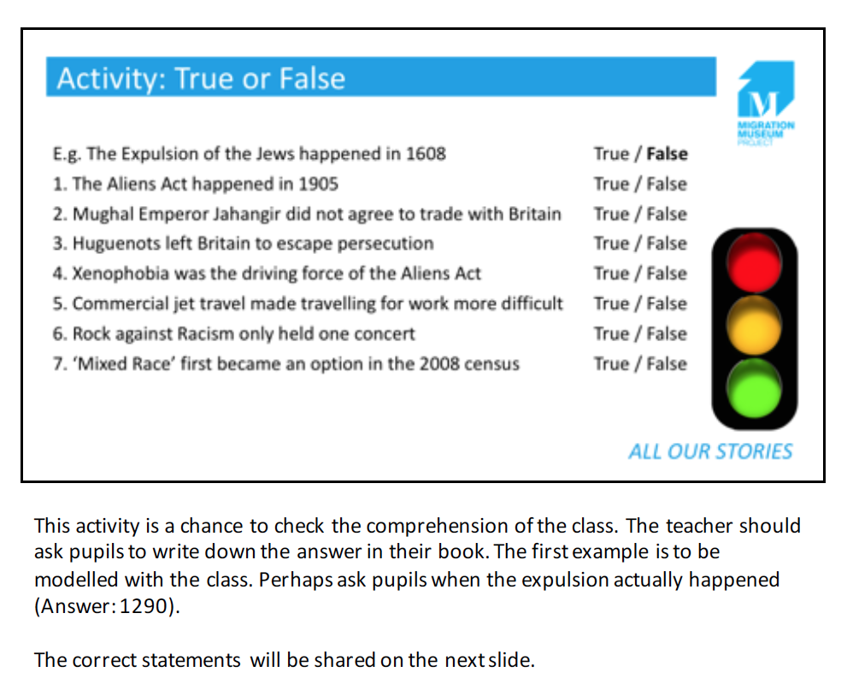

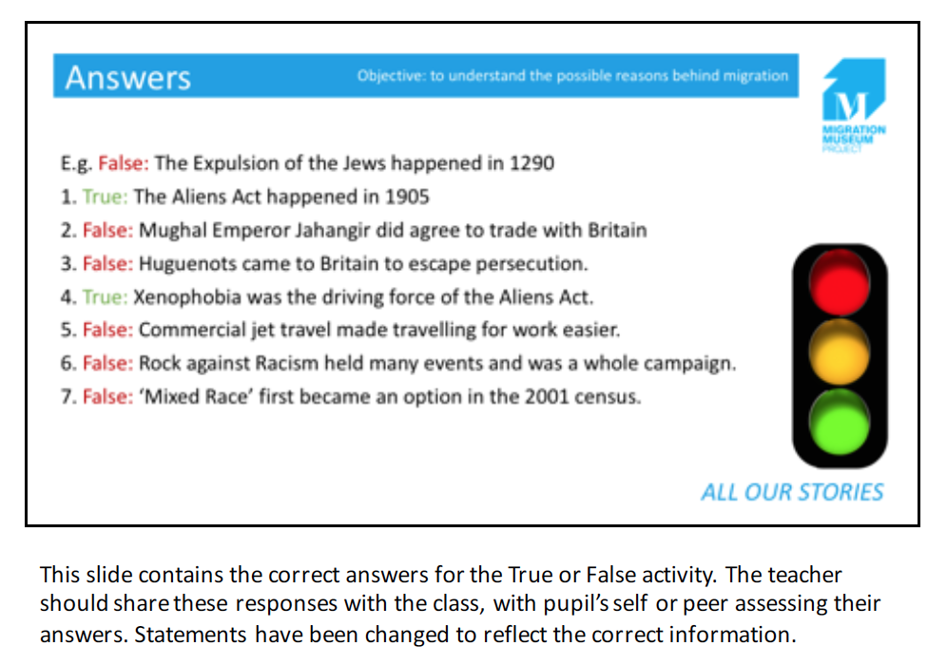
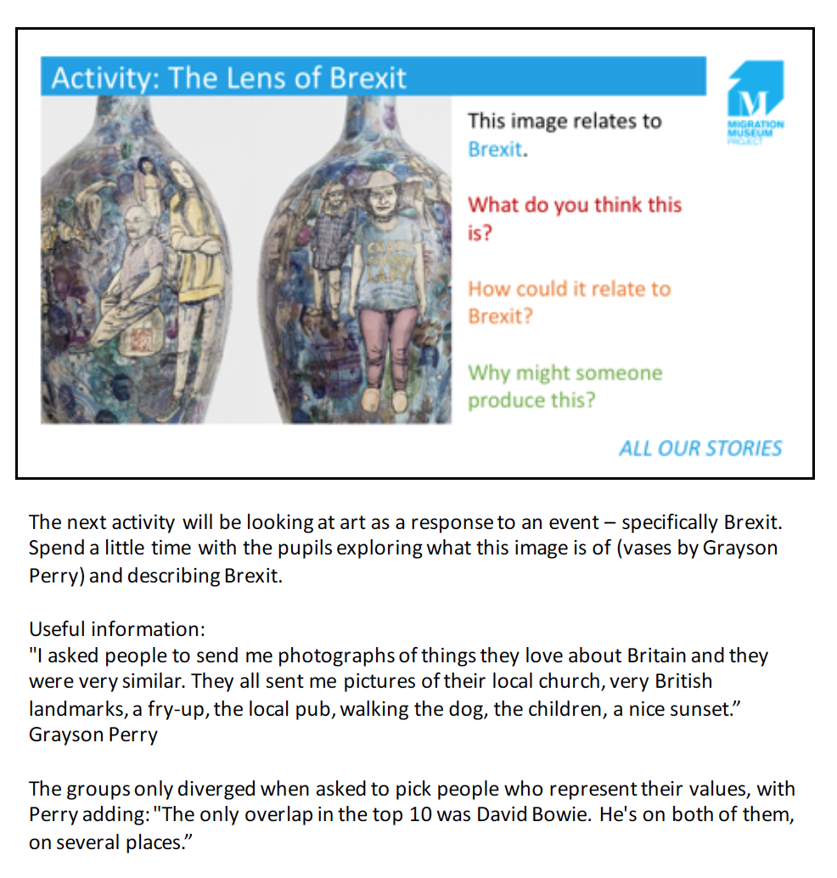
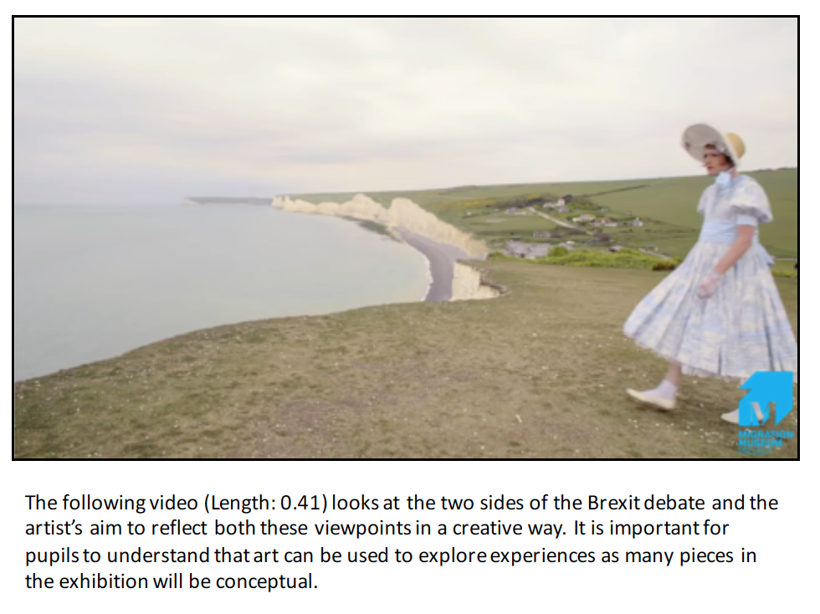

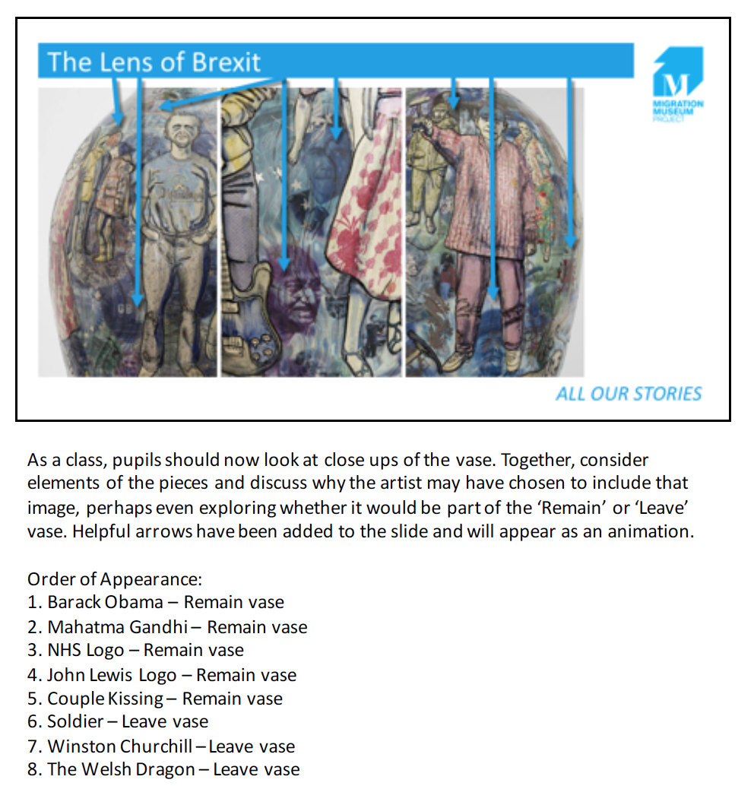

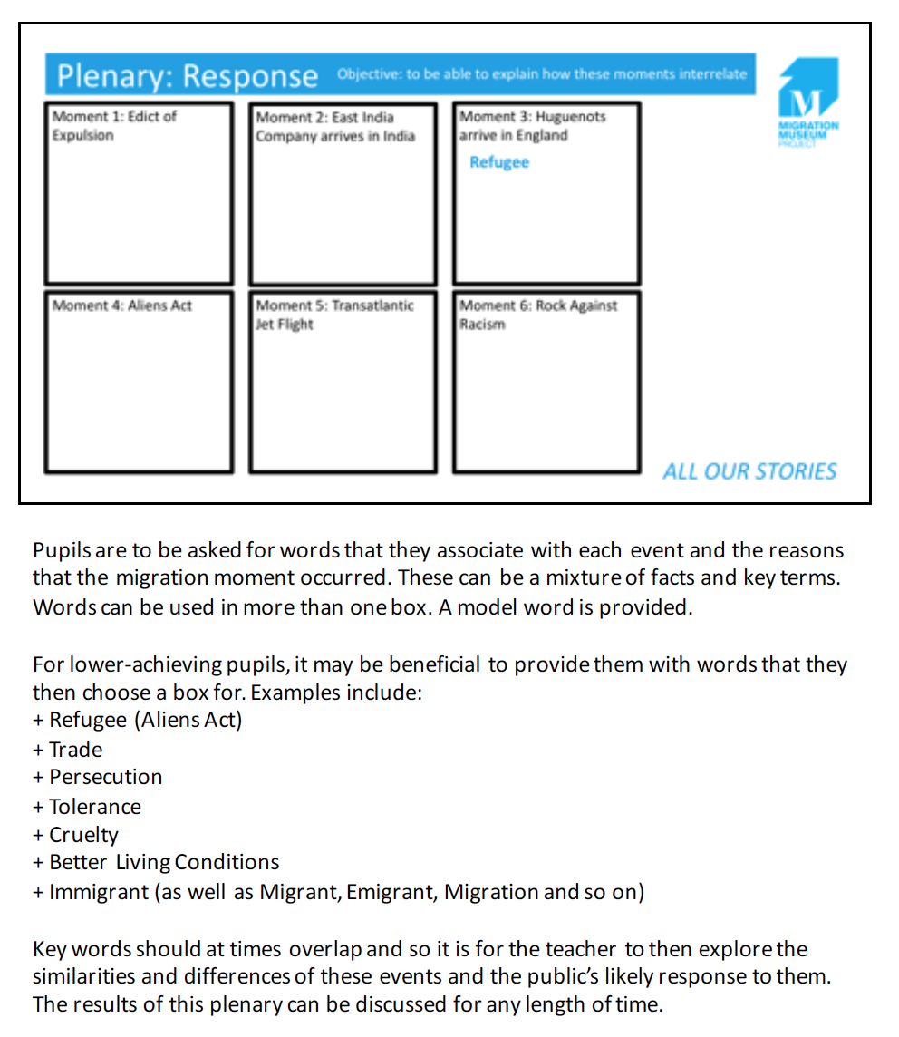

Outline of Post-Visit (Lesson 2)
Introduction: Thoughts on the Migration Museum (3 Minutes)
The teacher may like to receive feedback from pupils about the school trip.

Starter: What Can You Remember? (5 Minutes)
A recap on the seven moments that shaped Britain.

Lesson Objectives and Key Definitions (3 Minutes)
Certain key definitions and the lesson objectives should be shared with the class.

Activity: Role on the Wall (14 Minutes)
This asks pupils empathise with the motivations and experiences of a migrant.

Activity: Silent Debate (10 Minutes)
This is a chance for students to explore their own views on migration based on the exhibition as well as the work they have done in lessons.

Activity: Campaign Plan (15 Minutes)
An activity asking pupils to plan their own pieces of work to support a campaign.

Plenary: Presentation (10 Minutes)
This plenary allows the teacher to review the plans that the pupils have made.

Lesson 2 Slides and Notes
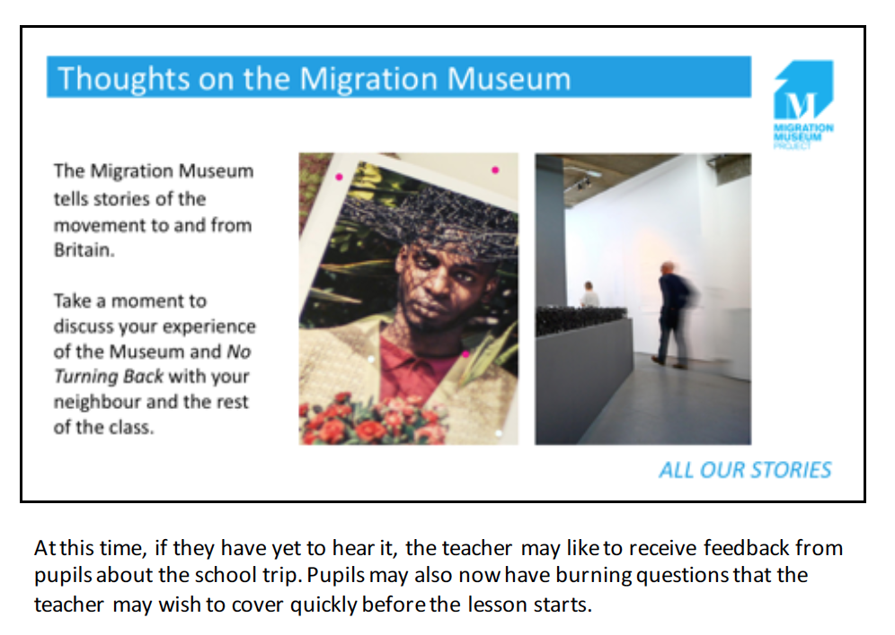

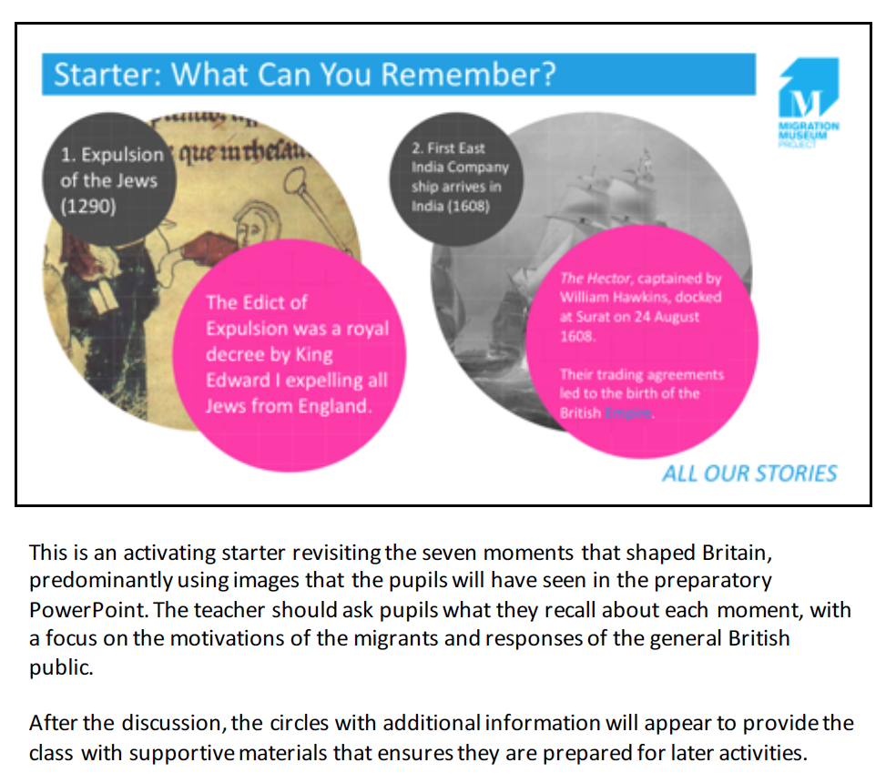

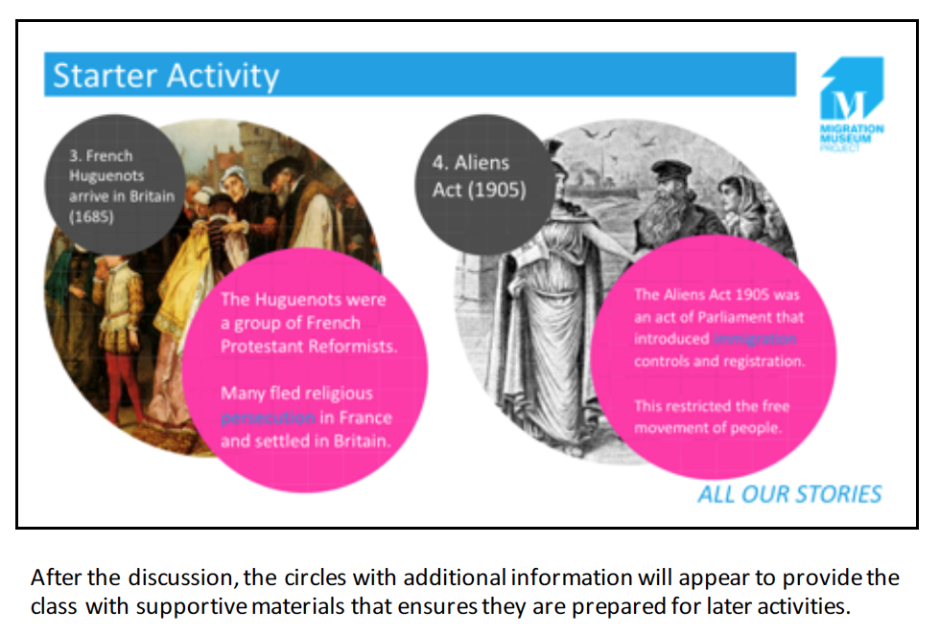

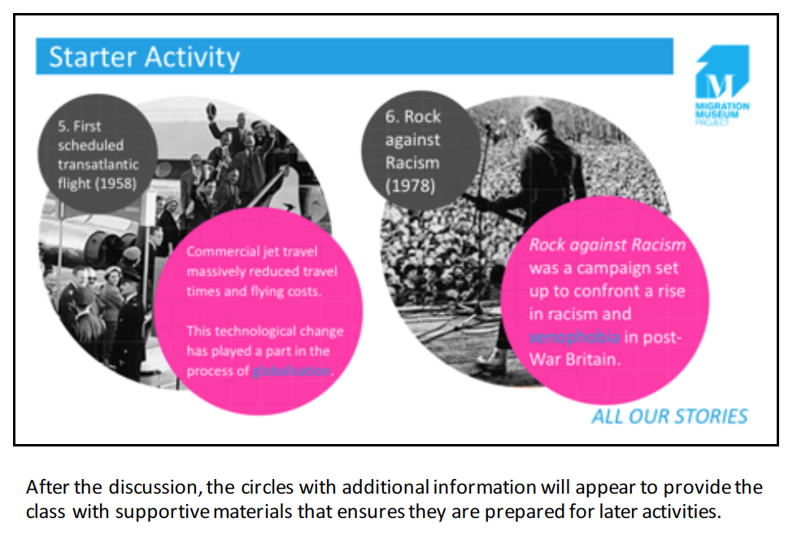

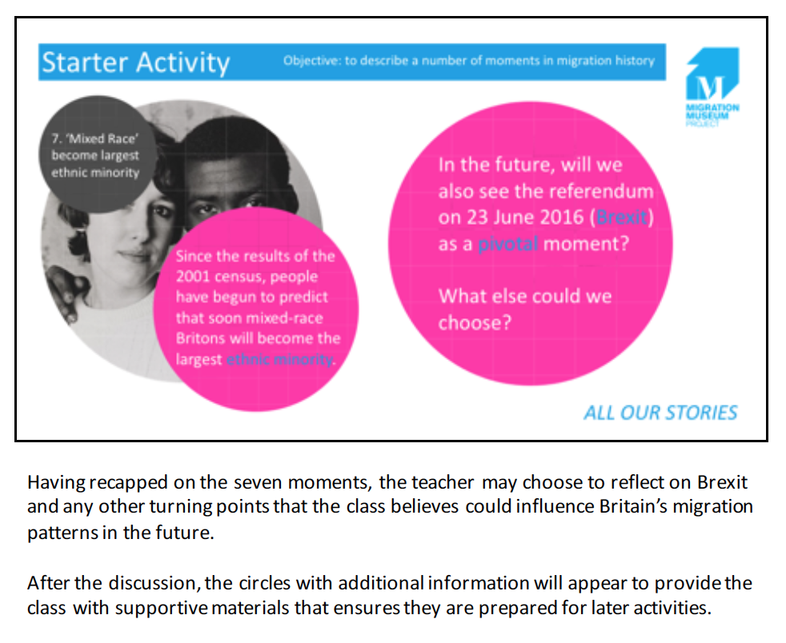

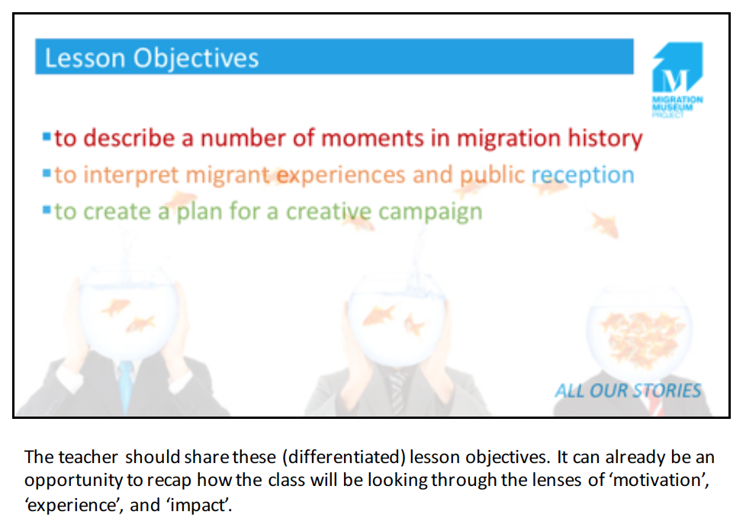
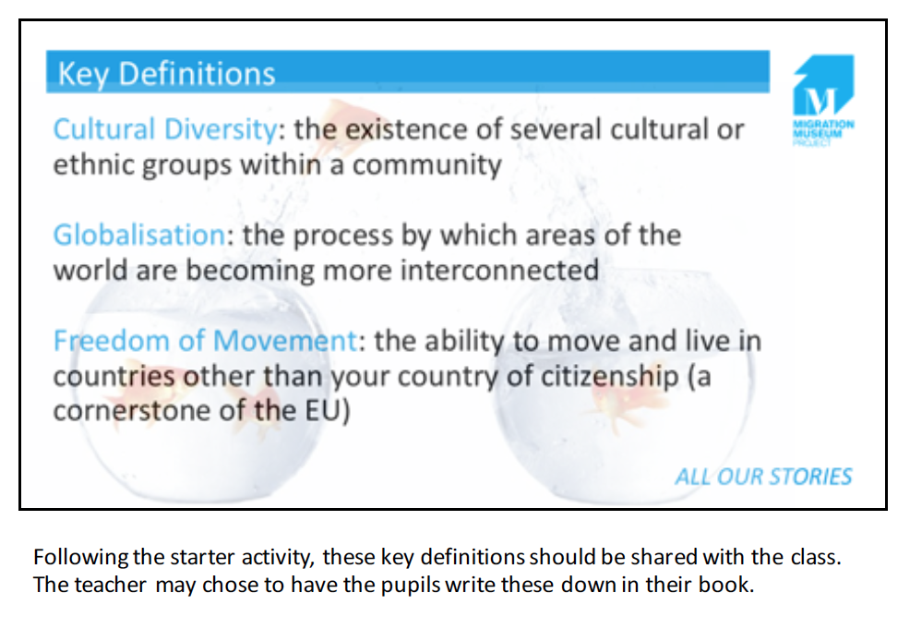

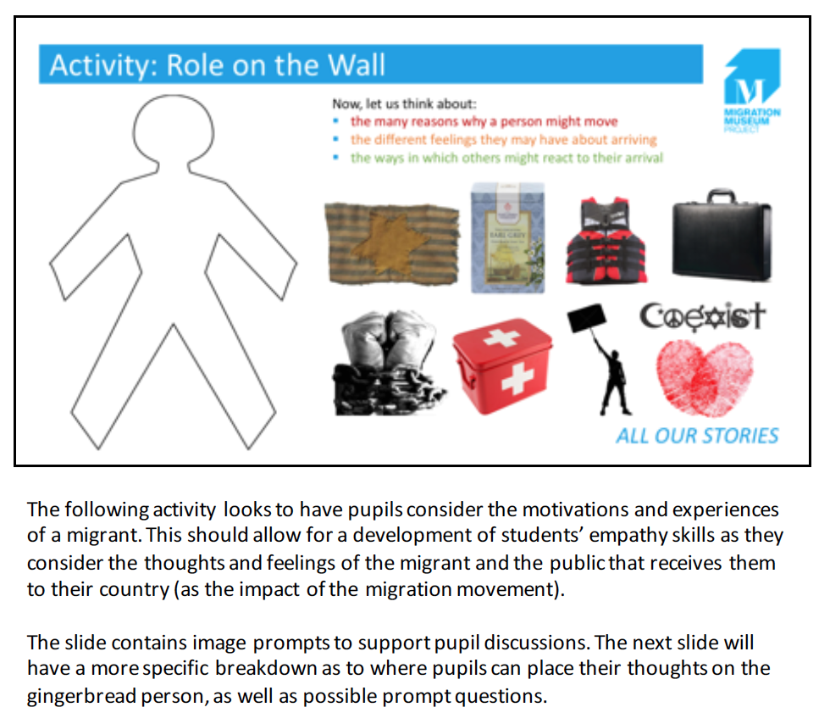

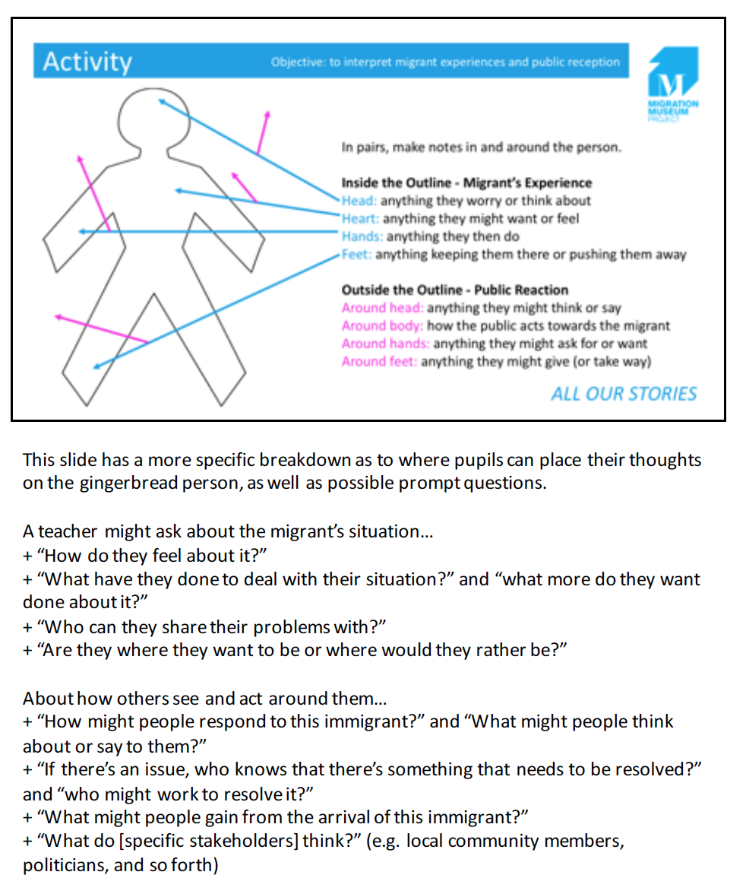

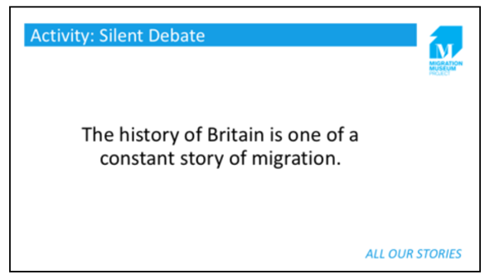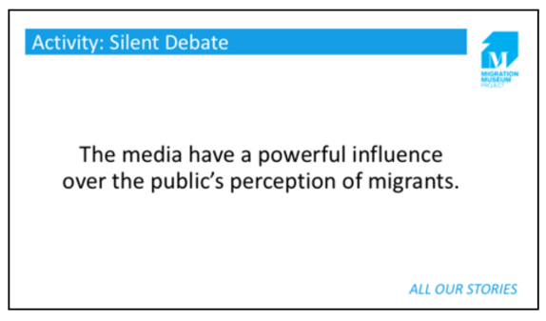
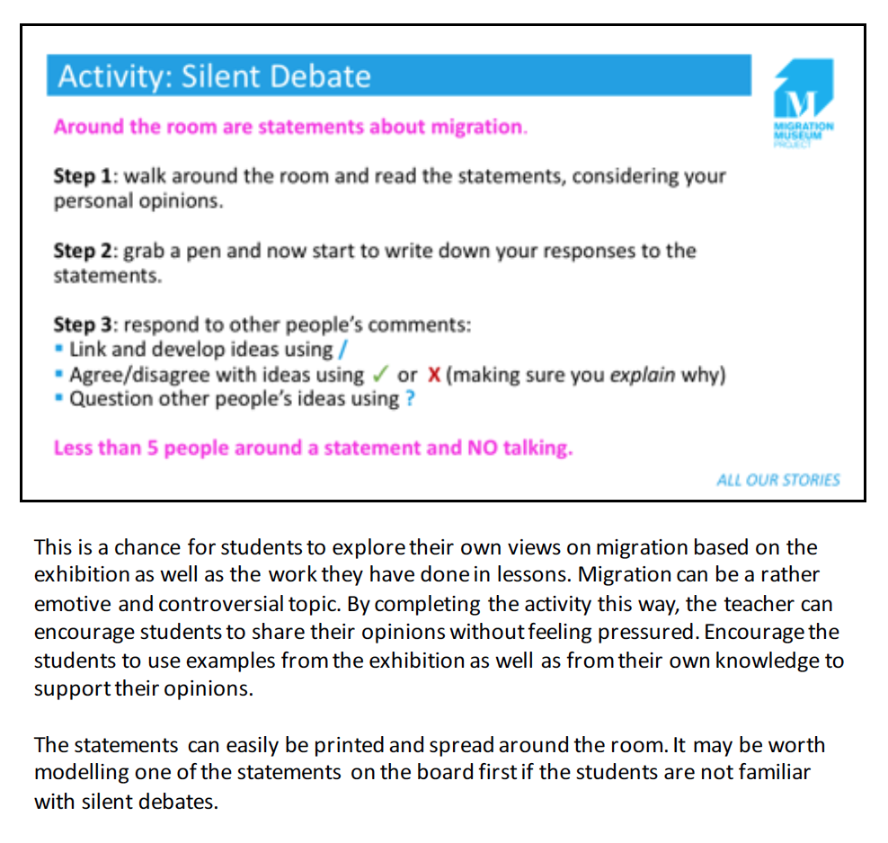

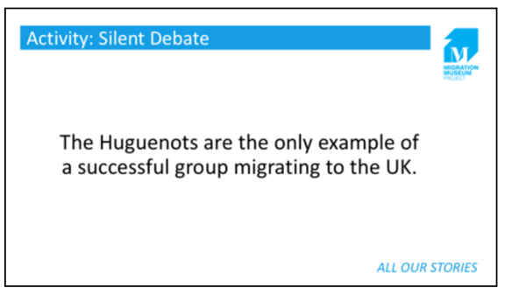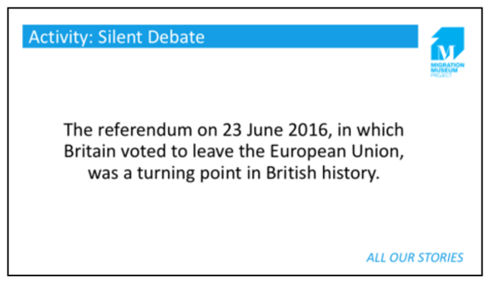
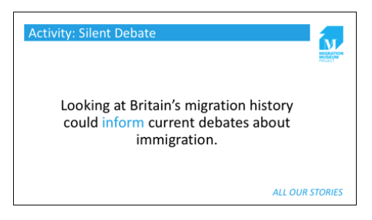

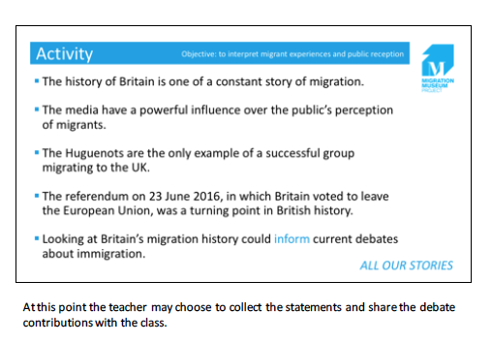

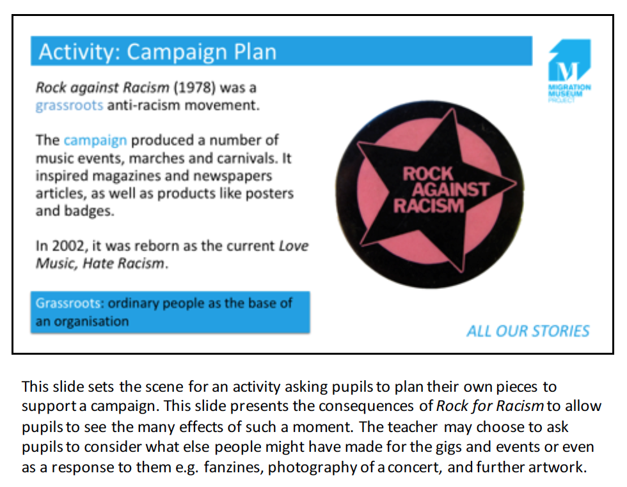

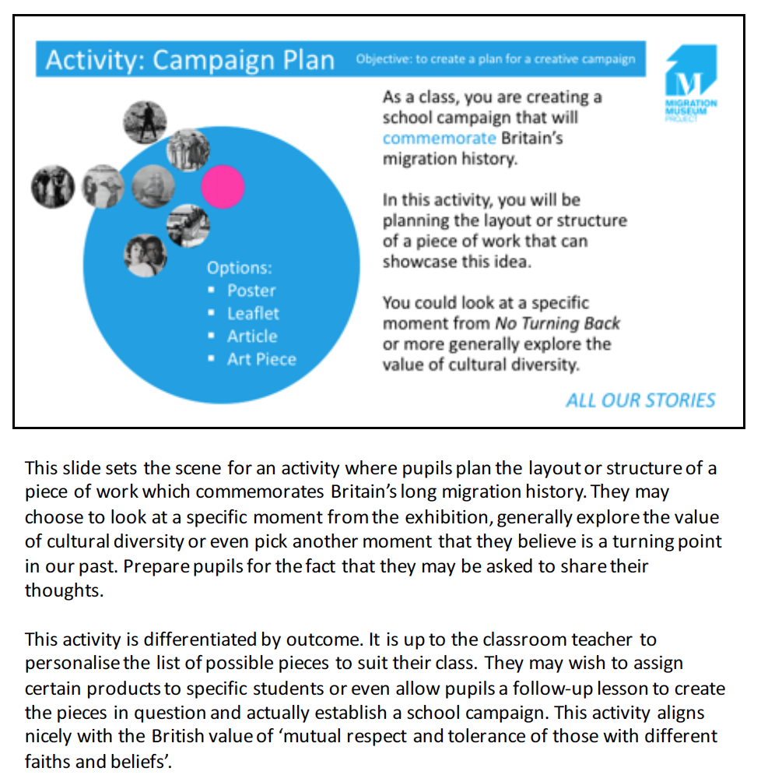
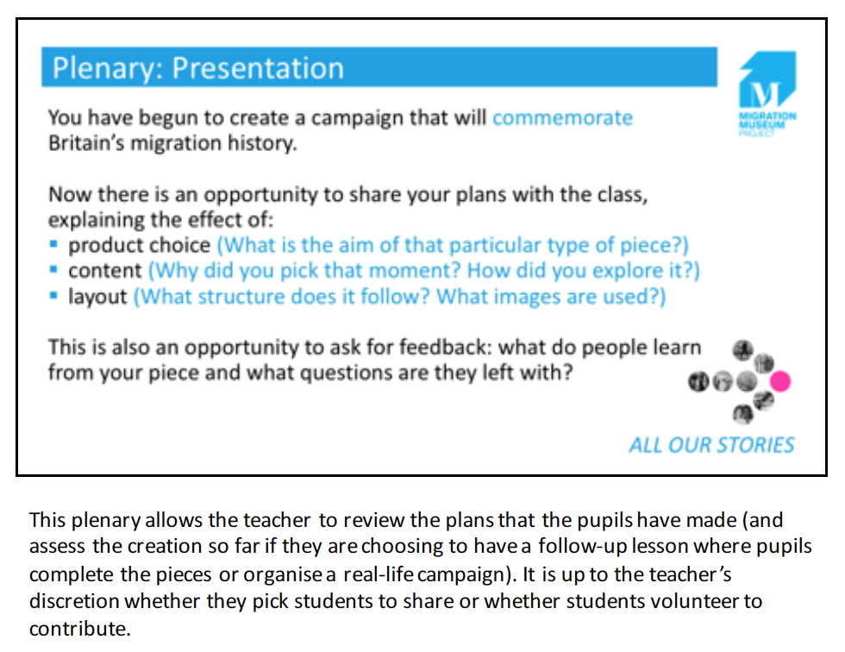

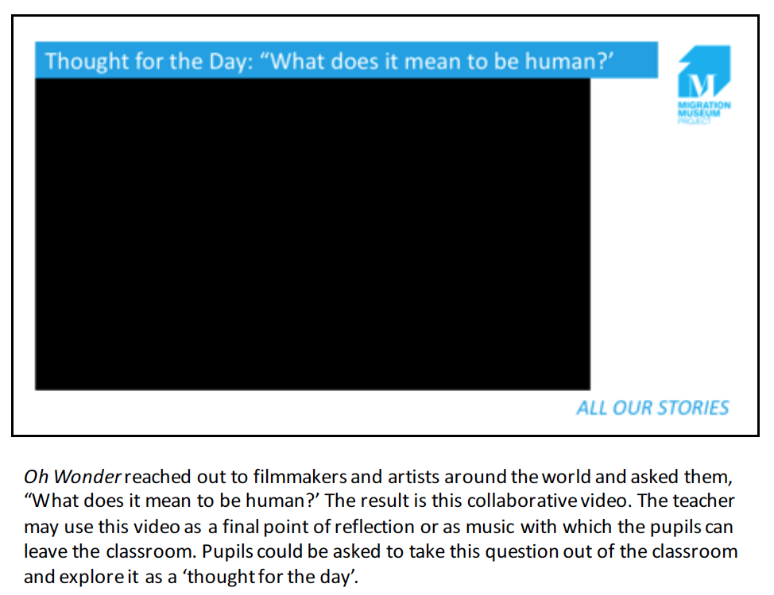

Engaging Students
The Migration Museum Project recognises that a class teacher will have the most meaningful understanding of their pupils’ path to developing historical understanding. Teachers are free to copy, edit and repurpose the No Turning Back resources for their best use within the classroom.

The resources have been designed to ensure lessons can be accessed easily wherever possible. ‘Red, Amber, Green’ questions and objectives allow for levels of challenge, while blue words will often have a definition provided or act as a visual prompt for teachers to check understanding in their class.

To allow even greater access, both in terms of raising literacy levels or challenging the more able and talented pupils, we have occasionally made suggestions for alternative versions of the activities. These can be found in italics in the ‘Notes’ portion of the lesson PowerPoint. An example can be seen below.

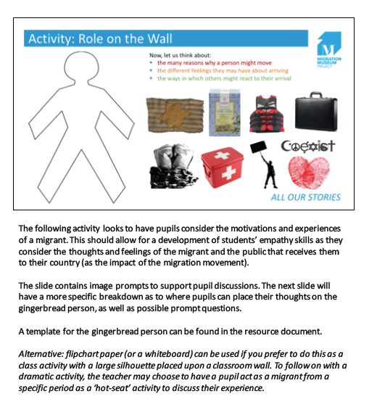

Acknowledgements
Lesson plan and materials created by Lottie Boumeester and Emma Reay
Additional editing by Liberty Melly and Emily Miller

